- Purpose/Description:
This record covers batch DNA extractions (for ___ samples) using the KingFisher Flex (adjust for number of samples)
- Responsibilities/Roles
Name (Print) | Signature | Initials

References/Attachments
Title | Doc #
MagMAX DNA Multi-Sample Ultra 2.0 Kit Protocol | Pub. No. MAN0017205 Rev. D.0  [Attached]
Sampling SOP | See portion attached
Nanodrop SOP | See copy in 3-ring binder
Qubit ds DNA Assay SOP | See copy in 3-4ing binder

- Equipment/Components
Equipment | Manufacturer-Model | Expiration/Calibration Due Date | Quantity Required or Used | Setup, pulled or verified by (Initials & Date) | Witness  (Initials & Date)
MagMax Plant DNA Isolation Kit  (prepped according to SOP VG004) | Cat. Nos. A32549, A32580, and A47156
1.5 mL tubes of 350 µL Lysis Buffer A with sample ID
Vortex
Incubator (preheat to 65°C)
1.5 mL tube chill rack
DNA Extractor | KingFisher Flex
Micropipette sets and tips:
P2, P20, P200, P1000, multichannel pipettors
Incubator set to 65 Celsius
Reservoir trays
50 mL conical tubes
Deepwell plates
Standard PCR plates
Spectrophotometer | Nanodrop
Flurometer | Qubit

- Performing Lysis/Manual Tissue Disruption (SOP VG004)
Record information for samples you are responsible for. For more than eight samples, record information in electronic batch record and/or lab notebook according to supervisor’s instructions.
Accession number | Plate, well, or tube ID | Approximate mg of leaf tissue used: 10 – 100 mg of fresh leaf (two hole punches) or < 20mg dry leaf | Date of manual tissue disruption | Performed/pulled by  (Initials/Date) | Witnessed by  (Initials/date)

Checklist. Performing lysis or manual tissue disruption steps (SOP VG004) on tissue samples and/or storing clarified lysates in freezer to use within seven days.
Steps | Performed by  (Initials/Date) | Witnessed by  (Initials/date)
Lysis buffer A (350 µL) to each 1.5 mL tube labelled with sample ID
For each sample, fold sampled leaf in half and punch a hole in each 1.5 mL microfuge tube using the cap (10 – 100 mg for fresh leaf tissue or 20 mg for dry leaf tissue).
Using a clean pestle for microfuge tubes, grind a sample in its tube for five minutes at room temperature.
Vortex 15 seconds and briefly spin down (1-2 seconds before reaching set speed) with tubes opposite each other.
Add lysis buffer B (50 µL) and RNase (50 µL).
Vortex to mix, incubate for 10 minutes in the 65°C heat block, water bath, or thermomixer while vortexing intermittently.
After incubating each tube, add precipitation buffer (130 µL).
Flip closed tubes upside down 2-3 times to mix.
Let tubes sit on ice or chill rack for 5 minutes.
Place pairs of tubes of equal volume opposite each other in centrifuge and spin down for five minutes at max speed (≥ 16,000 × g).
- Plate/Solution Setup
Solution | Lot # if  needed | Expiry  if  needed | Quantity req (per well) | Quantity used (n samples + 0.2 * n samples) | Performer Initials/Date | Witness Initials/Date
Wash I deepwell plate (position 2) | N/A | N/A | 800 uL
Deepwell Plates - positions 3 and 4: Wash II solution | N/A | N/A | 800 uL
Elution plate (position 5, standard plate) | N/A | N/A | 150 uL
Tip comb in deepwell (position 6) | N/A | N/A | N/A | N/A
Samples in deepwell plate | N/A | N/A | Plant lysate: 400 uL | N/A
 | N/A | N/A | DNA binding beads (vortex well): 25 uL  +  96-100% Ethanol: 400 uL | Mix:  Binding beads:  _____ uL  +  96-100% Ethanol  _____ uL

- Samples. Log ID abbreviation according to sampling records in table directly below or using plate temple further below.
Sample ID and Plate  Position | Amount of Lysate and Bead Mix added | Quantity Used Leaf Tissue (mg) | Performer Initials/Date | Witness Initials/Date
Sample ID: ______  Well: ___ | Lysate: ___ uL  Bead Mix: ___ uL
Sample ID: ______  Well: ___ | Lysate: ___ uL  Bead Mix: ___ uL
Sample ID: ______  Well: ___ | Lysate: ___ uL  Bead Mix: ___ uL
Sample ID: ______  Well: ___ | Lysate: ___ uL  Bead Mix: ___ uL
Sample ID: ______  Well: ___ | Lysate: ___ uL  Bead Mix: ___ uL
Sample ID: ______  Well: ___ | Lysate: ___ uL  Bead Mix: ___ uL

For many samples, record sample IDs and plate ID name (as should be written on side of plate):
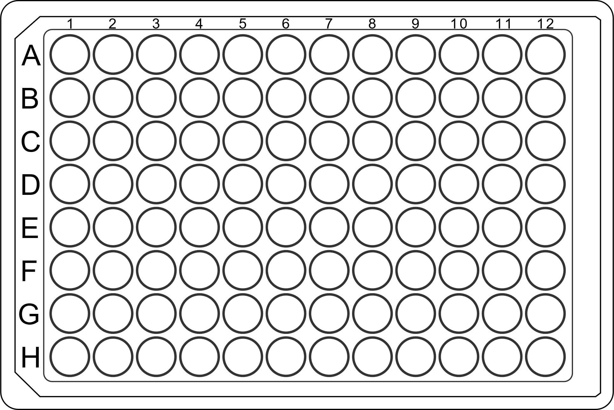
Plate ID: ____________; Stored Location (Room ID, Freezer ID, Box ID): _____,________,___________

- Process
# | Task | Performed Initial/Date | Verified Initial/Date
1 | Ensure that the instrument is set up for processing with the proper magnetic head (96 deep-well)  for your application.
2 | Ensure that the proper heat block (96 well standard, not deep-well) is installed for your application.
3 | Make sure solutions are prepared according to VG004 and Plate/Solution Setup
4 | Transfer the lysates into the corresponding wells of new plate for addition of bead mix.
6 | Setup all plates immediately on the Kingfisher Flex instrument.
7 | Select the program “A32549_Plant_DNA_Flex 96DW” on the instrument.
8 | Make sure plates are appropriately loaded into the instrument and start.
9 | When the run is complete, wear appropriate PPE and remove the samples for storage (-20C) or immediate use/testing.
10 | Perform  Concentration and Purity Assays and record information in electronic batch records, provided data sheets, or lab notebook (see SOP VG001, VG005, VG010 and their respective attachments).

